CS 250 Spring 2017 - Homework 01

Due 11:58pm Wednesday, January 18, 2017

**Submit your typewritten file in PDF format to Blackboard.**

The policy for all homework assignments this semester is as follows. Please sign, which you may do by typing in your name.

*In the following have not represented the work of another person as my own nor have I knowingly or actively assist another person in violating this standard.*

(Signed)__***Nicholas Donahue***_____________

1. How many distinct one-input Boolean functions are there?  
   To determine the amount of distinct n-input Boolean *functions* in existence you can use the equation $2^{2^{n}}$ where n is the number of inputs. In this case n = 1, therefore there are $2^{2^{1}}$ = 4 distinct one-input Boolean functions.
2. What is the truth table for the three-input NAND function? Extend the two-input NAND circuit in the text Figure 2.5 to accept three inputs and draw a schematic.

|  |  |  |  |
| --- | --- | --- | --- |
| **Truth Table for three-input NAND function** | | | |
| **A** | **B** | **C** | **____**  **A.B.C** |
| 0 | 0 | 0 | 1 |
| 0 | 0 | 1 | 1 |
| 0 | 1 | 0 | 1 |
| 0 | 1 | 1 | 1 |
| 1 | 0 | 0 | 1 |
| 1 | 0 | 1 | 1 |
| 1 | 1 | 0 | 1 |
| 1 | 1 | 1 | 0 |

*Circuit on next page…*

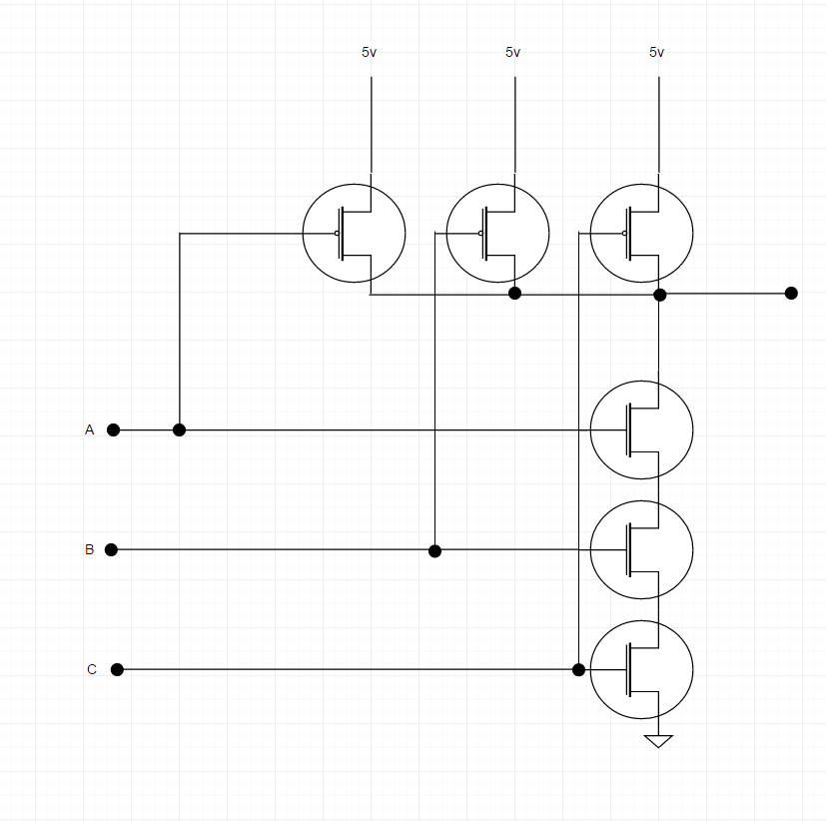

*Above image made at ‘draw.io’*

1. Using exactly 4 CMOS transistors, design and then draw a schematic for a NOR circuit. Comment on the relationship you see between the NAND circuit presented in class and our textbook and the NOR circuit that you develop.

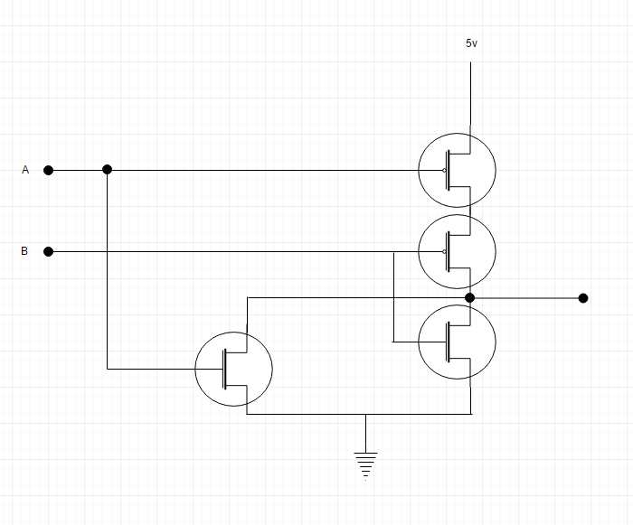

*Above image made at ‘draw.io’*

Both the NAND and the NOR circuits involve exactly 4 CMOS transistors – 2 negated and 2 normal. The circuit pattern and layout of these transistors is also the same, however the 5v and the ground points are switched around.

1. Name the Boolean function that this circuit implements.

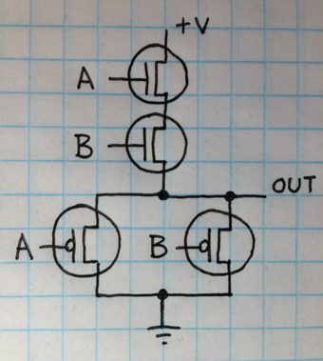

This circuit implements the AND Boolean function.

1. Let the input logic values to the following circuit be x=Don’t Care, y=0, and z=1. What is the logic value of the output f(x,y,z)?  
   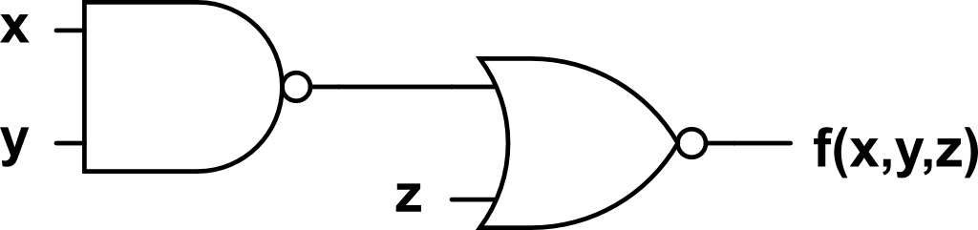

The logic value of the output f(x,y,z) = 0

The NAND of x and y is 1 because even though x is not given it doesn’t matter since the NAND of anything involving a zero input (in this case, y) results in a 1. The NOR of this input (which is 1) and the z=1 is simply 0.

1. Under what conditions does a full adder generate Sum = 0 and Carry out = 1 from Augend, Addend, and Carry in? Show your answer in the form of a table.

|  |  |  |  |  |
| --- | --- | --- | --- | --- |
| **Truth Table for Full Adder Circuit** | | | | |
| **Inputs** | | | **Outputs** | |
| Cin | A | B | S | Cout |
| 0 | 0 | 0 | 0 | 0 |
| 1 | 0 | 0 | 1 | 0 |
| 0 | 1 | 0 | 1 | 0 |
| 1 | 1 | 0 | 0 | 1 |
| 0 | 0 | 1 | 1 | 0 |
| 1 | 0 | 1 | 0 | 1 |
| 0 | 1 | 1 | 0 | 1 |
| 1 | 1 | 1 | 1 | 1 |

The shaded regions above indicate the conditions in which a full adder circuit generates Sum = 0 and Carry out = 1.

1. What is the key idea that shows how to use fundamentally analog circuits so that they behave digitally?

The key idea that shows how to use fundamentally analog circuits so that they behave digitally is the *use of a finite set of values (or digits)*, rather than the infinite expressiveness of analog. This allows numbers to be represented without any margin of error, thus behaving digitally.

1. What principle allows for the simplification of descriptions of hardware by omission of unimportant detail?

The principal that allows for the simplification of descriptions of hardware by omission of unimportant details is the strategic act of paring the description. By choosing to focus on breadth rather than the depth of the information we can trim off unnecessary details for easier understanding without losing any of that crucial information. An example of this is how the textbook explains a circuit (ex: NAND, AND, OR, XOR, etc.) through diagrams and simple descriptions instead of (the more complex and unnecessary) going into the physical structure and makeup or the flow of electrical flow within.

1. You are given (zero cost of acquisition) a Cray-2 and an iPad 2 and quality places to operate them. Assume that both computers has the same application program that you wish to run. Assertion: Since these computers are equally fast, you have no preference as to which one you use. State whether you agree or disagree with the assertion and explain why.

I disagree with the assertion. If I was given both a Cray-2 and an iPad 2 with the same application, operating space, and both zero cost of acquisition, I still would prefer the iPad 2 over the Cray-2. Since both devices are being supplied and used at the same exact way and their processing power is identical they would still run the application the same way, but the deciding factor here is now personal preference (which involves ease of use). I believe that people would find it easier to manage, hold, work with, and even manipulate the app with an iPad 2 rather than the giant, clunky, difficult Cray-2. The touch screen may also help alongside the fact that it is vastly smaller and more portable.